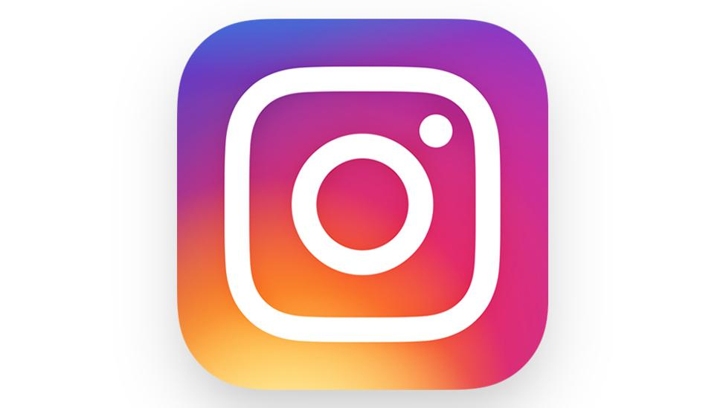

**Instagram Platform Dissection**

**Company Overview**

Instagram, launched in 2010 by Kevin Systrom and Mike Krieger, began as a photo-sharing application and quickly evolved into one of the world’s leading social media platforms. Acquired by Meta (formerly Facebook) in 2012, Instagram now offers a wide array of content types including photos, videos, Stories, Reels, and live streaming. It empowers users to connect, express themselves visually, and discover trends, influencers, and brands.

**Product Dissection and Real-World Problems Solved by Instagram**

Instagram addresses numerous real-world challenges in the digital age by offering tools for personal expression, social networking, marketing, and content discovery. It has fundamentally changed how individuals and businesses interact online, offering a visually-driven medium for storytelling and engagement.

**Problem 1: Limited Visual Expression and Connectivity**

**Real-World Challenge**: People previously had limited platforms to share visual experiences and connect with others in a meaningful, creative way.

**Instagram's Solution**: Instagram’s core feature—photo and video sharing—enables users to express their lives visually, while features like Stories, DMs, and comments foster real-time social interaction and engagement.

**Problem 2: Discoverability and Brand Visibility**

**Real-World Challenge**: Small businesses, creators, and influencers often struggle to reach audiences without significant marketing budgets.

**Instagram's Solution**: Through hashtags, Explore pages, Reels, and algorithm-driven content delivery, Instagram enhances discoverability and provides a low-cost platform for brand growth and audience building.

**Problem 3: Need for Real-Time Content and Engagement**

**Real-World Challenge**: Users want to stay updated and interact with their audience in real-time.

**Instagram's Solution**: Live streaming, Stories, and real-time comments allow creators and users to engage instantly, making the platform dynamic and responsive.

**Problem 4: Monetization for Creators**

**Real-World Challenge**: Creators and influencers often lack stable monetization models.

**Instagram's Solution**: Features like paid partnerships, in-app shopping, creator funds, and affiliate links help users monetize their content and following.

**Top Features of Instagram**

1. **User Profiles**: Each user has a customizable profile with a bio, profile picture, and highlights. It displays all posts, followers, and followings.
2. **Posts**: Users can upload photos or videos with captions, tags, and location data. Posts appear in the feed and are permanently visible unless deleted.
3. **Stories**: Temporary content (disappears after 24 hours), enabling real-time sharing and quick updates.
4. **Reels**: Short-form, engaging videos used to entertain, educate, or promote. Widely consumed and discoverable via Explore.
5. **Direct Messaging (DMs)**: Allows private conversations, sharing of posts, and video calls between users.
6. **Comments & Likes**: Engagement mechanisms for users to interact with content.
7. **Explore Page**: Curated feed of trending content tailored to user interests.
8. **Instagram Live**: Users can broadcast in real-time to their followers.
9. **Shopping**: Businesses can tag products directly in posts and Reels for in-app purchases.
10. **Ads & Promotions**: Sponsored content to target specific audiences and track engagement.

**Schema Description**

The Instagram platform consists of multiple entities managing users, posts, comments, likes, and messages.

**User Entity**

* **UserID (Primary Key):** A unique identifier assigned to every user upon registration. It serves as the primary key.
* **Username:** The chosen handle or profile name used to identify the user publicly and in mentions.
* **Email:** The users registered email address, used for login, communication, and password recovery.
* **Password:** A securely stored password that allows the user to log in to their account.
* **FullName:** The actual or displayed name of the user, visible on their profile.
* **ProfilePicture:** The link or path to the image that represents the user on their profile.
* **Bio:** A brief self-description added by the user, often used to express personality or links.
* **JoinDate:** The date when the user created their Instagram account.

**Post Entity**

* **PostID (Primary Key):** A unique identifier for each post, serving as its primary key.
* **UserID (Foreign Key):** A foreign key referencing the user who created the post.
* **Caption:** The text that accompanies the post, often used for context, hashtags, or expression.
* **MediaURL:** The path or URL to the actual media file (image or video).
* **PostDate:** The date and time when the post was published.
* **Location:** Optional information indicating where the photo/video was taken or posted from.

**Comment Entity**

* **CommentID (Primary Key):** A unique identifier for each comment.
* **PostID (Foreign Key):** A foreign key linking the comment to the post it belongs to.
* **UserID (Foreign Key):** A foreign key referencing the user who wrote the comment.
* **CommentText:** The content or body of the comment.
* **CommentDate:** The timestamp indicating when the comment was submitted.

**Like Entity**

* **LikeID (Primary Key):** A unique identifier for each like interaction.
* **PostID (Foreign Key):** A foreign key pointing to the post that received the like.
* **UserID (Foreign Key):** A foreign key referencing the user who liked the post.
* **LikeDate:** The date and time when the like was registered.

**Story Entity**

* **StoryID (Primary Key):** A unique identifier for each story item.
* **UserID (Foreign Key):** A foreign key linking the story to its creator.
* **MediaURL:** The location of the story's media (image or video).
* **PostedAt:** The timestamp marking when the story was uploaded.
* **ExpiresAt:** The calculated expiration time, typically 24 hours after posting.

**Message Entity**

* **MessageID (Primary Key):** A unique identifier for each message.
* **SenderID (Foreign Key):** A foreign key pointing to the user who sent the message.
* **ReceiverID (Foreign Key):** A foreign key pointing to the user who received the message.
* **MessageText:** The body of the message sent from one user to another.
* **SentAt:** The timestamp when the message was sent.

### Relationships between Entities

* A **User** can create multiple **Posts**, establishing a one-to-many (1:N) relationship.
* A **User** can publish multiple **Stories**, also a one-to-many relationship.
* A **Post** can have many **Comments**, with each comment linked to both a post and a user.
* A **Post** can receive multiple **Likes** from different users.
* A **User** can send and receive many **Messages**, forming two one-to-many relationships: one as sender, one as receiver.

**ER Diagram**

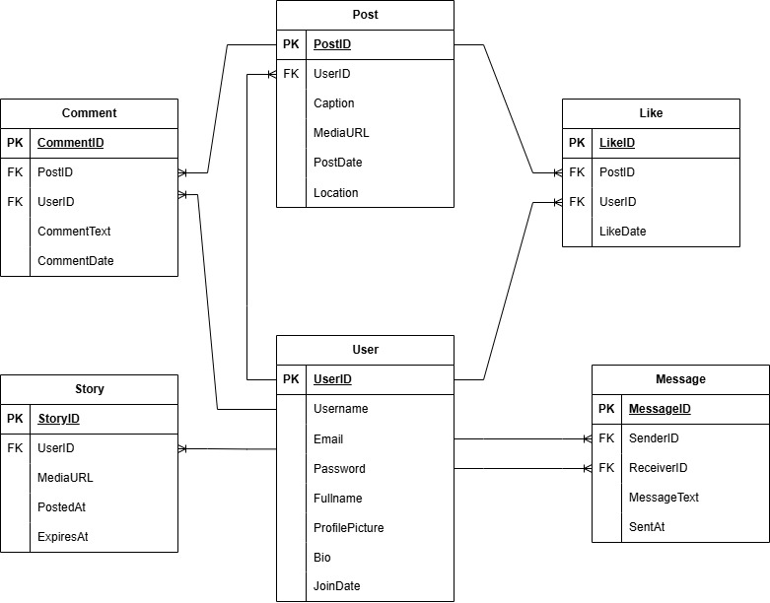

**Conclusion**

Instagram has reshaped modern communication, commerce, and digital expression. Its schema architecture supports millions of users with robust, scalable data handling for multimedia content, interactions, and messaging. By solving real-world problems—from expression to monetization—it remains a leading platform in the social media ecosystem.